**LAB EXERCISE – 4**

* RAMAKRISHNAN ILANGHOVAN (23BCE1489)

***1)***

***CODE:***

<!DOCTYPE html>

<html lang="en">

<head>

    <meta charset="UTF-8">

    <meta name="viewport" content="width=device-width, initial-scale=1.0">

    <title>Document</title>

</head>

<body>

    <fieldset>

        <legend>Login</legend>

        <form>

            <label for="username">Username*</label><br>

            <input type="text" id="username" name="username" required><br>

            <label for="password">Password*</label><br>

            <input type="password" id="password" name="password" required><br>

        </form>

    </fieldset>

    <fieldset>

        <legend>Gender</legend>

        <form action="">

            <input type="radio" name="gender" value="male"><label>Male</label>

            <input type="radio" name="gender" value="male"><label>Female</label>

        </form>

    </fieldset>

    <fieldset>

        <legend>Programming Skills</legend>

        <form>

            <input type="checkbox" name="Programming Skills" id="java">

            <label for="java">Java</label>

            <input type="checkbox" name="Programming Skills" id="C++" checked>

            <label for="C++">C++</label>

            <input type="checkbox" name="Programming Skills" id="C#">

            <label for="C#">C#</label>

        </form>

    </fieldset>

    <fieldset>

        <legend>Fruit</legend>

        <form>

            <label>Choose a Fruit </label>

            <select name="fruit" id="fruit">

                <optgroup label="Pome">

                    <option value="apple">Apple</option>

                    <option value="pear">Pear</option>

                </optgroup>

                <optgroup label="Citrus">

                    <option value="orange">Orange</option>

                    <option value="grapefruit">Grapefruit</option>

                    <option value="mandarin">Mandarins</option>

                    <option value="lime">Limes</option>

                </optgroup>

                <optgroup label="Stone">

                    <option value="nectarine">Nectarines</option>

                    <option value="apricot">Apricots</option>

                    <option value="peach">Peaches</option>

                    <option value="plum">Plums</option>

                </optgroup>

                <optgroup label="Exotic">

                    <option value="banana">Banana</option>

                    <option value="mango">Mango</option>

                </optgroup>

                <optgroup label="Berries">

                    <option value="strawberry">Strawberries</option>

                    <option value="raspberry">Raspberries</option>

                    <option value="blueberry">Blueberries</option>

                    <option value="kiwifruit">Kiwifruit</option>

                    <option value="passionfruit">Passionfruit</option>

                </optgroup>

                <optgroup label="Melons">

                    <option value="watermelon">Watermelons</option>

                    <option value="rockmelon">Rock-melons</option>

                    <option value="honeydew">Honeydew melons</option>

                </optgroup>

            </select>

        </form>

    </fieldset>

    <br>

    <textarea rows="5" cols="50" name="" id="" placeholder="Enter your comment here"></textarea><br>

    <button>Send</button>

    <button>Reset</button>

</body>

</html>

***OUTPUT:***

***2)***

***CODE:***

<!DOCTYPE html>

<html lang="en">

<head>

    <meta charset="UTF-8">

    <meta name="viewport" content="width=device-width, initial-scale=1.0">

    <title>Document</title>

</head>

<body>

    <fieldset>

        <legend><b><font color="red">Personal Details</font></b></legend>

        <form>

            <br>

            <label for="Name">Name &emsp;  &emsp; :</label>

            <input type="text" name="Name"><br><br>

            <label for="Password">Password &emsp;:</label>

            <input type="password" name="Password"><br><br>

            <label for="Email">Email &emsp; &emsp; :</label>

            <input type="email" name="Email"><br><br>

            <label for="Gender">Gender &emsp; &nbsp; &nbsp;:</label>

            <input type="radio" name="Gender"><label>Male</label>

            <input type="radio" name="Gender"><label>Female</label><br><br>

            <label for="DOB">DOB &emsp; &emsp; &nbsp;:</label>

            <input type="date" name="Password"><br><br>

            <label for="Mobile#">Mobile# &emsp; &nbsp;:</label>

            <input type="tel" name="Mobile#" pattern="[0-9]{10}">

        </form>

    </fieldset>

    <br><br>

    <fieldset>

        <legend><font color="red"><b>Educational Qualification</b></font></legend>

        <form action="">

            <br>

            <label for="Degree">Degree &emsp; :</label>

            <select name="Degree" id="">

                <optgroup label="UG" id="">

                    <option value="">BE</option>

                    <option value="">BTech</option>

                    <option value="">Bsc</option>

                    <option value="">BA</option>

                    <option value="">BCA</option>

                    <option value="">BBA</option>

                    <option value="">Others</option>

                </optgroup>

                <optgroup label="PG" id="">

                    <option value="">ME</option>

                    <option value="">MTech</option>

                    <option value="">MSc</option>

                    <option value="">MA</option>

                    <option value="">MCA</option>

                    <option value="">MBA</option>

                    <option value="">Others</option>

                </optgroup>

                <optgroup label="PhD" id="">

                    <option value="">Engineering</option>

                    <option value="">Science</option>

                    <option value="">Management</option>

                    <option value="">Others</option>

                </optgroup>

            </select>

            <label for="Engineering">Engineering: </label>

            <select name="Engineering" >

                <option value="Select group">-- Select Group --</option>

                <option value="CSE">CSE</option>

                <option value="ECE">ECE</option>

                <option value="EEE">EEE</option>

                <option value="CIVIL">CIVIL</option>

                <option value="MECH">MECH</option>

            </select>

        </form>

    </fieldset>

    <br>

    <label for="Hobbies">Hobbies &emsp; &nbsp;:</label>

    <input type="checkbox" id="Hobbies" name="Hobbies" value="PlayingChess"><label for="PlayingChess">PlayingChess</label>

    <input type="checkbox" id="Hobbies" name="Hobbies" value="Reading Books"><label for="Reading Books">Reading Books</label>

    <br><br>

    <label for="Color">Favourite Color: </label>

    <input type="color" name="Color">

    <br><br>

    <label for="Address"><font color="red"><b>Address</b></font></label><br><br>

    <input type="text" size="50">

    <br><br>

    <label for="Attach Resume:">Attach Resume: </label>

    <input type="file" name="Attach Resume:">

    <button type="submit">Submit</button>

</body>

</html>

***OUTPUT:***

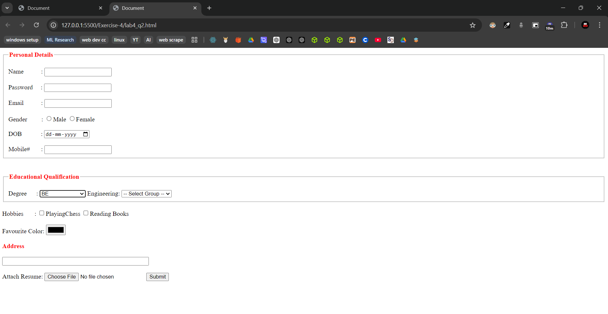

***3)***

***CODE:***

<!DOCTYPE html>

<html lang="en">

<head>

    <meta charset="UTF-8">

    <meta name="viewport" content="width=device-width, initial-scale=1.0">

    <title>Document</title>

</head>

<body>

    <b>FeedBack form</b>

    <form oninput="x.value = parseInt(a.value) + parseInt(b.value) + parseInt(c.value)">

        0<input type = "range" id = "a" value = "0">100<br>

        0<input type = "range" id = "b" value = "0">100<br>

        0<input type = "range" id = "c" value = "0">100<br>

        = <output id = "x"></output></output>

    </form>

</body>

</html>

***OUTPUT:***

